**Figure S1.** Correlation Between Autophagy Pathways and Prognostic Genes in MM.

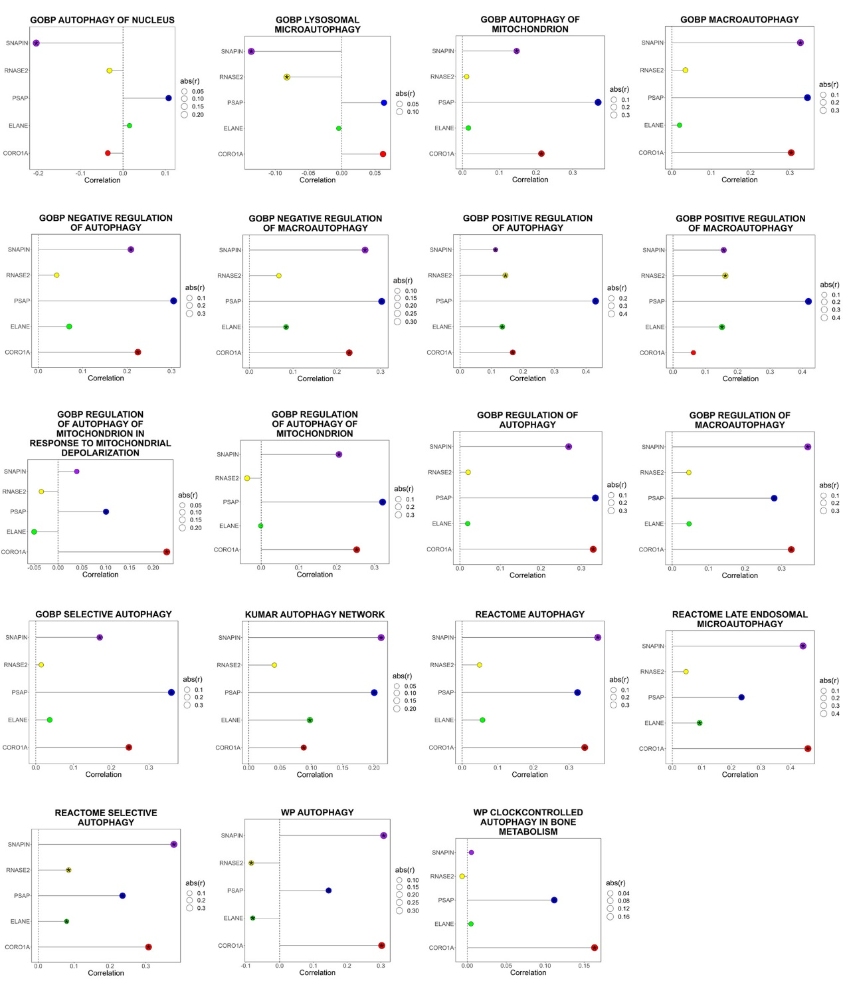

**Table S1** Primer sequences.

|  |  |  |
| --- | --- | --- |
| Gene name | Primer sequences (5’-3’) | Size |
| CORO1A (Human) | Forward: CTGTGCTGTCAACCCTAAGTTT | 111 bp |
|  | Reverse: GTGGGCGCATTCTTGTCCA |
| ELANE (Human) | Forward: CTCGCGTGTCTTTTCCTCG | 185 bp |
|  | Reverse: GCCGACATGACGAAGTTGG |  |
| PSAP (Human) | Forward: CCCGGTCCTTGGACTGAAAG | 145 bp |
|  | Reverse: TATGTCGCAGGGAAGGGATTT |  |
| RNASE2 (Human) | Forward: TGTGGTAACCCAAATATGACCTG | 196 bp |
|  | Reverse: GGTCTCGTCGTTGATCTCTGT |  |
| SNAPIN (Human) | Forward: CAGCAGCTCGACTCTCACG | 81 bp |
|  | Reverse: TTCTGTGGCTAGGTTGTCAATTT |  |
| GAPDH (Human) | Forward: GAAGGTCGGAGTCAACGGAT | 133 bp |
|  | Reverse: CTTCCCGTTCTCAGCCATGT |  |